Sunday, January 30th, 2022

**Today’s Message**

**Title:** Sermon on the Mount: Rock or Sand **Text:** Matthew 7:21-29

**Speaker:** Zach Bollman – Lead Minister

_______________ and _______________ cannot save.

Build your _______________ on the _______________.

_______________ is _______________.

**Welcome!**

We are glad you are here! At our church we are committed to loving God, loving others, and making disciples. Our service is designed to help you better experience God as we worship Him as our Lord and Savior. We begin each service with announcements and a call to worship. During the service, we praise the Lord with singing, remember His death and celebrate His resurrection by partaking of Communion, and hear a message from the Bible. We end each service with a time of invitation for prayer. Enjoy, participate, but above all - remember that Jesus loves you and so do we!

***Do you want to be saved and obtain eternal life?***

Simply turn from your sins and trust Jesus Christ for your salvation. Confess that Jesus is Lord and believe that He died on the cross to pay the price for your sins and that His resurrection guarantees your eternal life. Be baptized by water to outwardly express that you have committed your life to Jesus. Water baptism is a command given to every believer and symbolizes our unity with Christ in His death and resurrection.

(John 3:16, Acts 2:38, Acts 3:19, Romans 3:23, Romans 6:4-5, Romans 10:9)

*\*If you or someone you know would like to commit their life to Christ, please contact someone on our leadership team, or visit our Connect Center.*

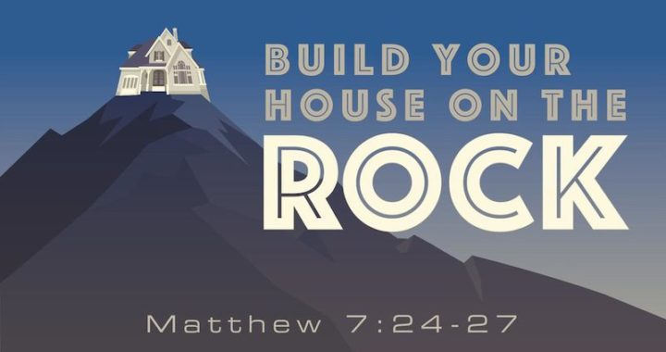

**Connect**

Fill out a **Connect Card**.

Visit our website **fellowshipinchrist.org.**

Download the **Our Church** app and search for

**Fellowship in Christ Christian Church.**

**Wi-Fi Name:** Fellowship in Christ

**Wi-Fi Password:** Fellowship3

**Prayer Needs**

Please keep the following in your prayers: Heather Mitchem, Alice Ann Olano, Jason Beckham, Blayn Bollman, Aaron Shoff, Webb Hardison, Kayleigh Colarines, Georgia Johnston, Roger and Dawn Westbrooks, Don McCain, Don and Mary Beth Chandler, Roshanda Vaughn, Brent McGee, Matt Uhles, Tim Schmidt, and John Heidlebaugh,

*\*If you have a prayer need you would like to include on the list, please visit our Connect Center.*

**January Meditation Verse: Revelation 21:5**

Then He who sat on the throne said, “Behold, I make all things new.” And He said to me, “Write, for these words are true and faithful.”

*\*Childcare is provided for all ages at every service.*

*For more information, please visit our Connect Center.*

**Sunday Service**

**9:45AM** Sunday School

**10:30AM** Worship

**Wednesday Service** **7PM** Church History Series

**Announcements**

* **The Church Building Project has begun!**
* **Men’s Group** – Saturday, February 19th at 9AM
* **Women’s Group** – Saturday, February 19th at 9AM
* **Annual Congregation Update** – Sunday, February 27th after the service

**Communion**

|  |  |  |
| --- | --- | --- |
| Today | February 6th | February 13th |
| Dan S. | Jim S. | Lyndon F. |

|  |
| --- |
|  |