Sunday, October 24th, 2021

**Welcome!**

We are glad you are here! At our church we are committed to loving God, loving others, and making disciples. Our service is designed to help you better experience God as we worship Him as our Lord and Savior. We begin each service with announcements and a call to worship. During the service, we praise the Lord with singing, remember His death and celebrate His resurrection by partaking of Communion, and hear a message from the Bible. We end each service with a time of invitation for prayer. Enjoy, participate, but above all - remember that Jesus loves you and so do we!

**Today’s Message**

**Title:** Sermon on the Mount: How to Pray **Text:** Matthew 6:5-15

**Speaker:** Zach Bollman – Lead Minister

God _______________ us to _______________.

There is a _______________ way to _______________.

Pray in the _______________ of _______________.

***Do you want to be saved and obtain eternal life?***

Simply turn from your sins and trust Jesus Christ for your salvation. Confess that Jesus is Lord and believe that He died on the cross to pay the price for your sins and that His resurrection guarantees your eternal life. Be baptized by water to outwardly express that you have committed your life to Jesus. Water baptism is a command given to every believer and symbolizes our unity with Christ in His death and resurrection.

(John 3:16, Acts 2:38, Acts 3:19, Romans 3:23, Romans 10:9, Romans 6:4-5)

*\*If you or someone you know would like to commit their life to Christ, please contact someone on our leadership team, or visit our Connect Center.*

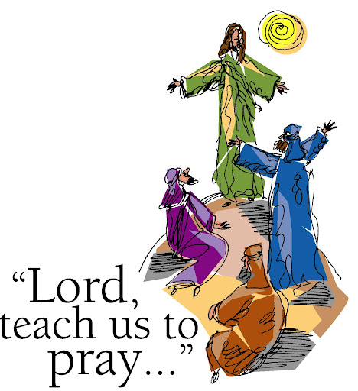

**Connect**

Fill out a **Connect Card**.

Visit our website **fellowshipinchrist.org.**

Download the **Our Church** app and search for

**Fellowship in Christ Christian Church.**

**Wi-Fi Name:** Fellowship in Christ

**Wi-Fi Password:** Fellowship3

**Announcements**

* **Danyelle Loury’s Baby Shower** – Sunday, October 24th at 2PM (FICCC)
* **Men’s Group: Mirage (Chapter 3)** – Saturday, November 20th from 9AM-10:30AM
* **Women’s Group: The Armor of God (Section 3)** – Saturday, November 20th from 9AM-10:30AM
* **Serve at the Community Thanksgiving Meal** – Thursday, November 25th at 10:30AM

**Prayer Needs**

* **Health:** Pray for Roger Westbrook, Walter Griggs, Michael Frangello, Wayne Mars, Don McCain, Roshanda Vaughn, Brent McGee, Matt Uhles, Tim Schmidt, and Brandie Beasley.
* **Loss:** Pray for the Kiefers, Neslers, Coffees, Uhles, and Borums.
* **Provision:** Pray for the Lozada Family and Carl Abbott
* **Pray for our Military and Nation.**
* **Pray for the Church.**

*\*If you have a prayer need you would like to include on the list, please visit our Connect Center.*

*\*Childcare is provided for all ages at every service.*

*For more information, please visit our Connect Center.*

**Communion**

|  |  |  |
| --- | --- | --- |
| Today | October 31st | November 7th |
| Mike F. | Russell R. | Lyndon F. |

|  |
| --- |
|  |

**October Meditation Verse: Matthew 5:48**

Therefore you shall be perfect, just as your Father in heaven is perfect.

**Wednesday Service** **7PM** Bible Study: Revelation 20

**7PM** Youth Group (TBA)

**Sunday Service**

**9:45AM** Sunday School

**10:30AM** Worship