

**Sunday, June 20th, 2021**

Loving God • Loving Others • Making Disciples



fellowshipinchrist.org

**Today’s Message**

**Title:** The Greatest Test Of All **Text:** Genesis 22:1-19

**Speaker:** Zach Bollman - Lead Minister

Notes:

**Expect _______________ from _______________.**

**_______________ is expressed by _______________ obedience.**

**The _______________ will _______________.**

***Do you want to be saved and obtain eternal life?***

*Simply turn from your sins and trust Jesus Christ for your salvation. Confess that Jesus is Lord and believe that He died on the cross to pay the price for your sins and that His resurrection guarantees your eternal life. Be baptized by water to outwardly express that you have committed your life to Jesus. Water baptism is a command given to every believer and symbolizes our unity with Christ in His death and resurrection.*

*(John 3:16, Acts 2:38, Acts 3:19, Romans 3:23, Romans 10:9, Romans 6:4-5)*

*If you or someone you know would like to commit their life to Christ, please contact someone on our leadership team, or visit our Connect Center.*

**Welcome!**

**Whether you are visiting, or this is your church home - relax. We are glad you are here! Our service is designed to help you better experience God in our midst as we worship Him as our Lord and Savior. We begin each service with Announcements and a Call to Worship, followed by Praise and Worship. We celebrate Communion every week before we hear a Message from Scripture. We end every service with an Invitation and Prayer. Enjoy, participate, but above all - remember that Jesus loves you and so do we!**

**Wednesday, June 23rd** **7PM** A Study on the Book of Revelation

**Sunday, June 20th**

**10:15AM** Fellowship

**10:30AM** Worship

**Come and Grow with Us!**

**Announcements**

**HAPPY FATHER’S DAY!**

* **Promise Keepers Men’s Conference** – Friday, July 16th @ 6PM & Saturday, July 17th @ 9AM
* **Women's Group** – Saturday, July 17th from 9-10:30AM

**Prayer Needs**

* **Health:** Pray for physical healing for the following individuals: John Shelton, Mike Frangello, Brandie Beasley, Halina Szubert, Bob Boehm, Andrea Loury, John Heidlebaugh, Sarah Quinones, and Willie Aaron.
* **Military:** Pray for Justin Cross and Steven Loury for safety and protection.
* **Nation:** Pray for peace, unity, and revival in our country.
* **Church:** Pray the church continues to love God, love others, and make disciples.

*\*If you have a prayer need you would like to include on the list, please visit our prayer wall at fellowshipinchrist.org, or visit our Connect Center.*

**June Meditation Verse: Psalm 94:12**

Blessed *is* the man whom You instruct, O Lord,

and teach out of Your law.

**Communion**

|  |  |  |
| --- | --- | --- |
| Today | June 27th | July 4th |
| Lyndon F. | Dan S. | Jim S. |

|  |
| --- |
|  |

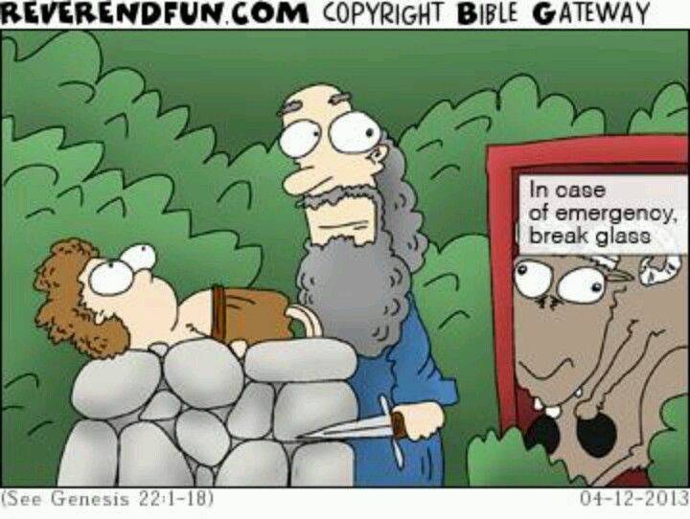

**Connect**

Fill out a **Connect Card** and turn it in to the Connect Center!

Visit us on Facebook, YouTube, and fellowshipinchrist.org

Download the **Our Church** app and search for

**Fellowship in Christ Christian Church**

**Wi-Fi Name:** Fellowship in Christ

**Wi-Fi Password:** Fellowship3