

Sunday, March 7th, 2021

Loving God • Loving Others • Making Disciples

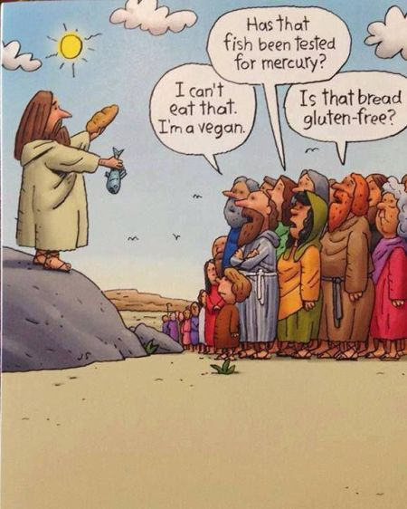

***Do you want to be saved and obtain eternal life?***

*Simply turn from your sins and trust Jesus Christ for your salvation. Believe that Jesus is Lord and that He died on the cross to pay the price for your sins and that His resurrection guarantees your eternal life. (John 3:16, Acts 3:19, Romans 3:23, Romans 10:9)*

***Do you want to be baptized?***

*Water baptism is the outward expression of the inner reality of those who trust in Jesus as their Lord and Savior. Baptism symbolizes our unity with Christ in His death and resurrection and is the first act of obedience for the believer. (Acts 2:38, Romans 6:4-5)*

*If you or someone you know would like to be baptized, please contact someone on our leadership team, or visit our Connect Center.*

**Today’s Message**

**Title:** Is God Not A Good Enough King? **Text:** 1 Samuel 8:6-7

**Speaker:** Dan Shasteen – Elder

Notes:

**Welcome!**

**Whether you are visiting, or this is your church home - relax. We are glad you are here! Our service is designed to help you better experience God in our midst as we worship Him as our Lord and Savior. We begin each service with Announcements and a Call to Worship, followed by Praise and Worship. We celebrate Communion every week before we hear a Message from Scripture. We end every service with an Invitation and Prayer. Enjoy, participate, but above all - remember that Jesus loves you and so do we!**

fellowshipinchrist.org

**Announcements:**

* **Ministerial Alliance Lent Service** – Wednesday, March 10th at 12PM (First Baptist Church)
* **Men's Group** – Saturday, March 20th from 9-10:30AM
* **Women's Group** – Saturday, March 20th from 9-10:30AM
* **Annual Congregation Update** – Sunday, March 21st immediately after the service
* **Good Friday Service** – Friday, April 2nd at 7PM

**Prayer Needs:**

* **Health:** Pray for Sarah Quinones for physical healing. Pray for John Heidlebaugh for physical healing. Pray for Willie Aaron for physical healing.
* **Family:** Pray for Stephanie Williams who recently lost her husband. Pray for Dillon and Ashley Lascelles for a safe pregnancy.
* **FICCC in the Military:** Pray for Justin Cross and Steven Loury.
* **Church:** Pray the church continues to love God, love others, and make disciples.
* **Nation:** Pray for peace, unity, and revival in our country.

*\*If you have a prayer need you would like to include on the list, please visit our prayer wall at fellowshipinchrist.org, or visit our Connect Center.*

**March Meditation Verse: Romans 1:16**

For I am not ashamed of the gospel of Christ, for it is the power of God to salvation for everyone who believes, for the Jew first and also for the Greek.

**Volunteer Schedule:**

|  |  |  |  |
| --- | --- | --- | --- |
|  | **This Week** | March 14th | March 21st |
| Communion | Jim S. | Dan S. | Mike F. |
| Nursery | TBA | TBA | TBA |
| Wednesday Meal | TBA | TBA | TBA |

*\*If you are not able to serve when scheduled, please find a replacement. Thank you!*

**Connect:**

Fill out a **Connect Card** and turn it in to the Connect Center!

Visit us on Facebook, YouTube, and fellowshipinchrist.org

Download the **Our Church** app and search for

**Fellowship in Christ Christian Church**

**Wi-Fi Name:** Fellowship in Christ

**Wi-Fi Password:** Fellowship3

**Wednesday, March 10th**  **7PM** Study: The Parables of Jesus

**Sunday, March 7th**

**10:15AM** Fellowship

**10:30AM** Worship

**Come and Grow with Us!**